Proceedings of the 1017th Regular weekly meeting of the club corresponding to the 8th meeting of Rotary year 2013-14 of Rotary Club of Sher-e-Banglanagar, Dhaka held on 07th September 2013 at 7:00 PM at Rapport Bangladesh Seminar Hall, Dhaka.

Meeting Called to order :

Rtn. Farida Parveen, President, Rotary Club of Sher-e-Banglanagar, Dhaka hereby called 1017th regular weekly meeting to order. She welcomed everybody and requested them to join the singing of the national anthem in chorus.

National Anthem :
National anthem was led by Rtn. Farida Parveen.

Rotary Invocation :
Rtn. PP ABM Sharif Hossain led the Rotary Invocation.

The following members were Present/Absent in the meeting on 07th September 2013

Sl.No. | Members Present | Sl.No. | Members Absent
01 | Rtn. Dr. M. Mosharraf Hossain | 01 | IPP Rtn. M. Ali Hossain
02 | Rtn. Farida Parveen | 02 | Rtn. A B M Siddiq
03 | Rtn. Shibbir Ahmed Khan | 03 | PP Rtn. Dr. Shariful Islam
04 | Rtn. Asim Tarafder | 04 | Rtn. Md. Nazim Uddin
05 | Rtn. Bodoruzzaman Chowdhury | 05 | PP Rtn. Sukriti Mukherjee
06 | PP Rtn. M. A. Latif | 06 | PP Rtn. Dr. Abdus Sobhan
07 | Rtn. Gofran Ahmed | 07 | Rtn. Fariduddin Ahmmad
08 | PP Rtn. M. R. Khan | 08. | PP Rtn. Tayebur Rahman
09 | PP Rtn. ABM Sharif Uddin | 09 | Rtn. Shahinoor Rahman
 |  | 10 | Rtn. Anwar Hossain
 |  | 11 | Rtn. Aahmed A Nabin
 | Percentage of Absent 55%

Felicitations:
There was no felicitation in this week.

President’s Mail:
No President’s mail was in this week.

Make-up by:
There was no advance make-up by the Rotarian.

Member Guest:
There was no member guest.

Club Guest:
There was no club guest.
Day’s Program:

The meeting started as per Agenda and the following agenda were discussed & adopted:

Installation:
Installation date will be fixed depending on the availability of venue (Dhaka Club), preferably on any Saturday in September or first week of October 2013.

Make up meeting by PDG in two clubs in USA :
President requested Rtn. Dr. M. Mosharraf Hossain, PDG to share his experience of his make-up meeting in two clubs in USA. Then he shared his experience. Everybody listened that experience minutely.

Secretary’s Announcement:

Rtn. Sibbir Ahmed Khan, Club Secretary conducted the club business and announced that :

The 1018th regular weekly meeting of the club corresponding to the 9th meeting of Rotary Year 2013-14 would be held on 14th September, 2013 (Saturday) at 6:30 P.M. at RAPPORT Bangladesh Ltd., Dhaka.

Statistics of the Day:

Club Statistics was given by Rtn. Asim Tarafder

Meeting No. 1017
Members on Roll 20
Members Present 09
Advance Make-up 00
Attendance Percentage 45%
Visiting Rotarians 00
Percentage of last meeting 35%

1st Comer of the Meeting : 1st comer of the meeting Rtn. Sibbir Ahmed Khan.

There being no other agenda the meeting was adjourned with a vote of thanks to the Chair.

Rtn. Farida Parveen Rtn. Shibbir Ahmed Khan
President Secretary
Photo gallery
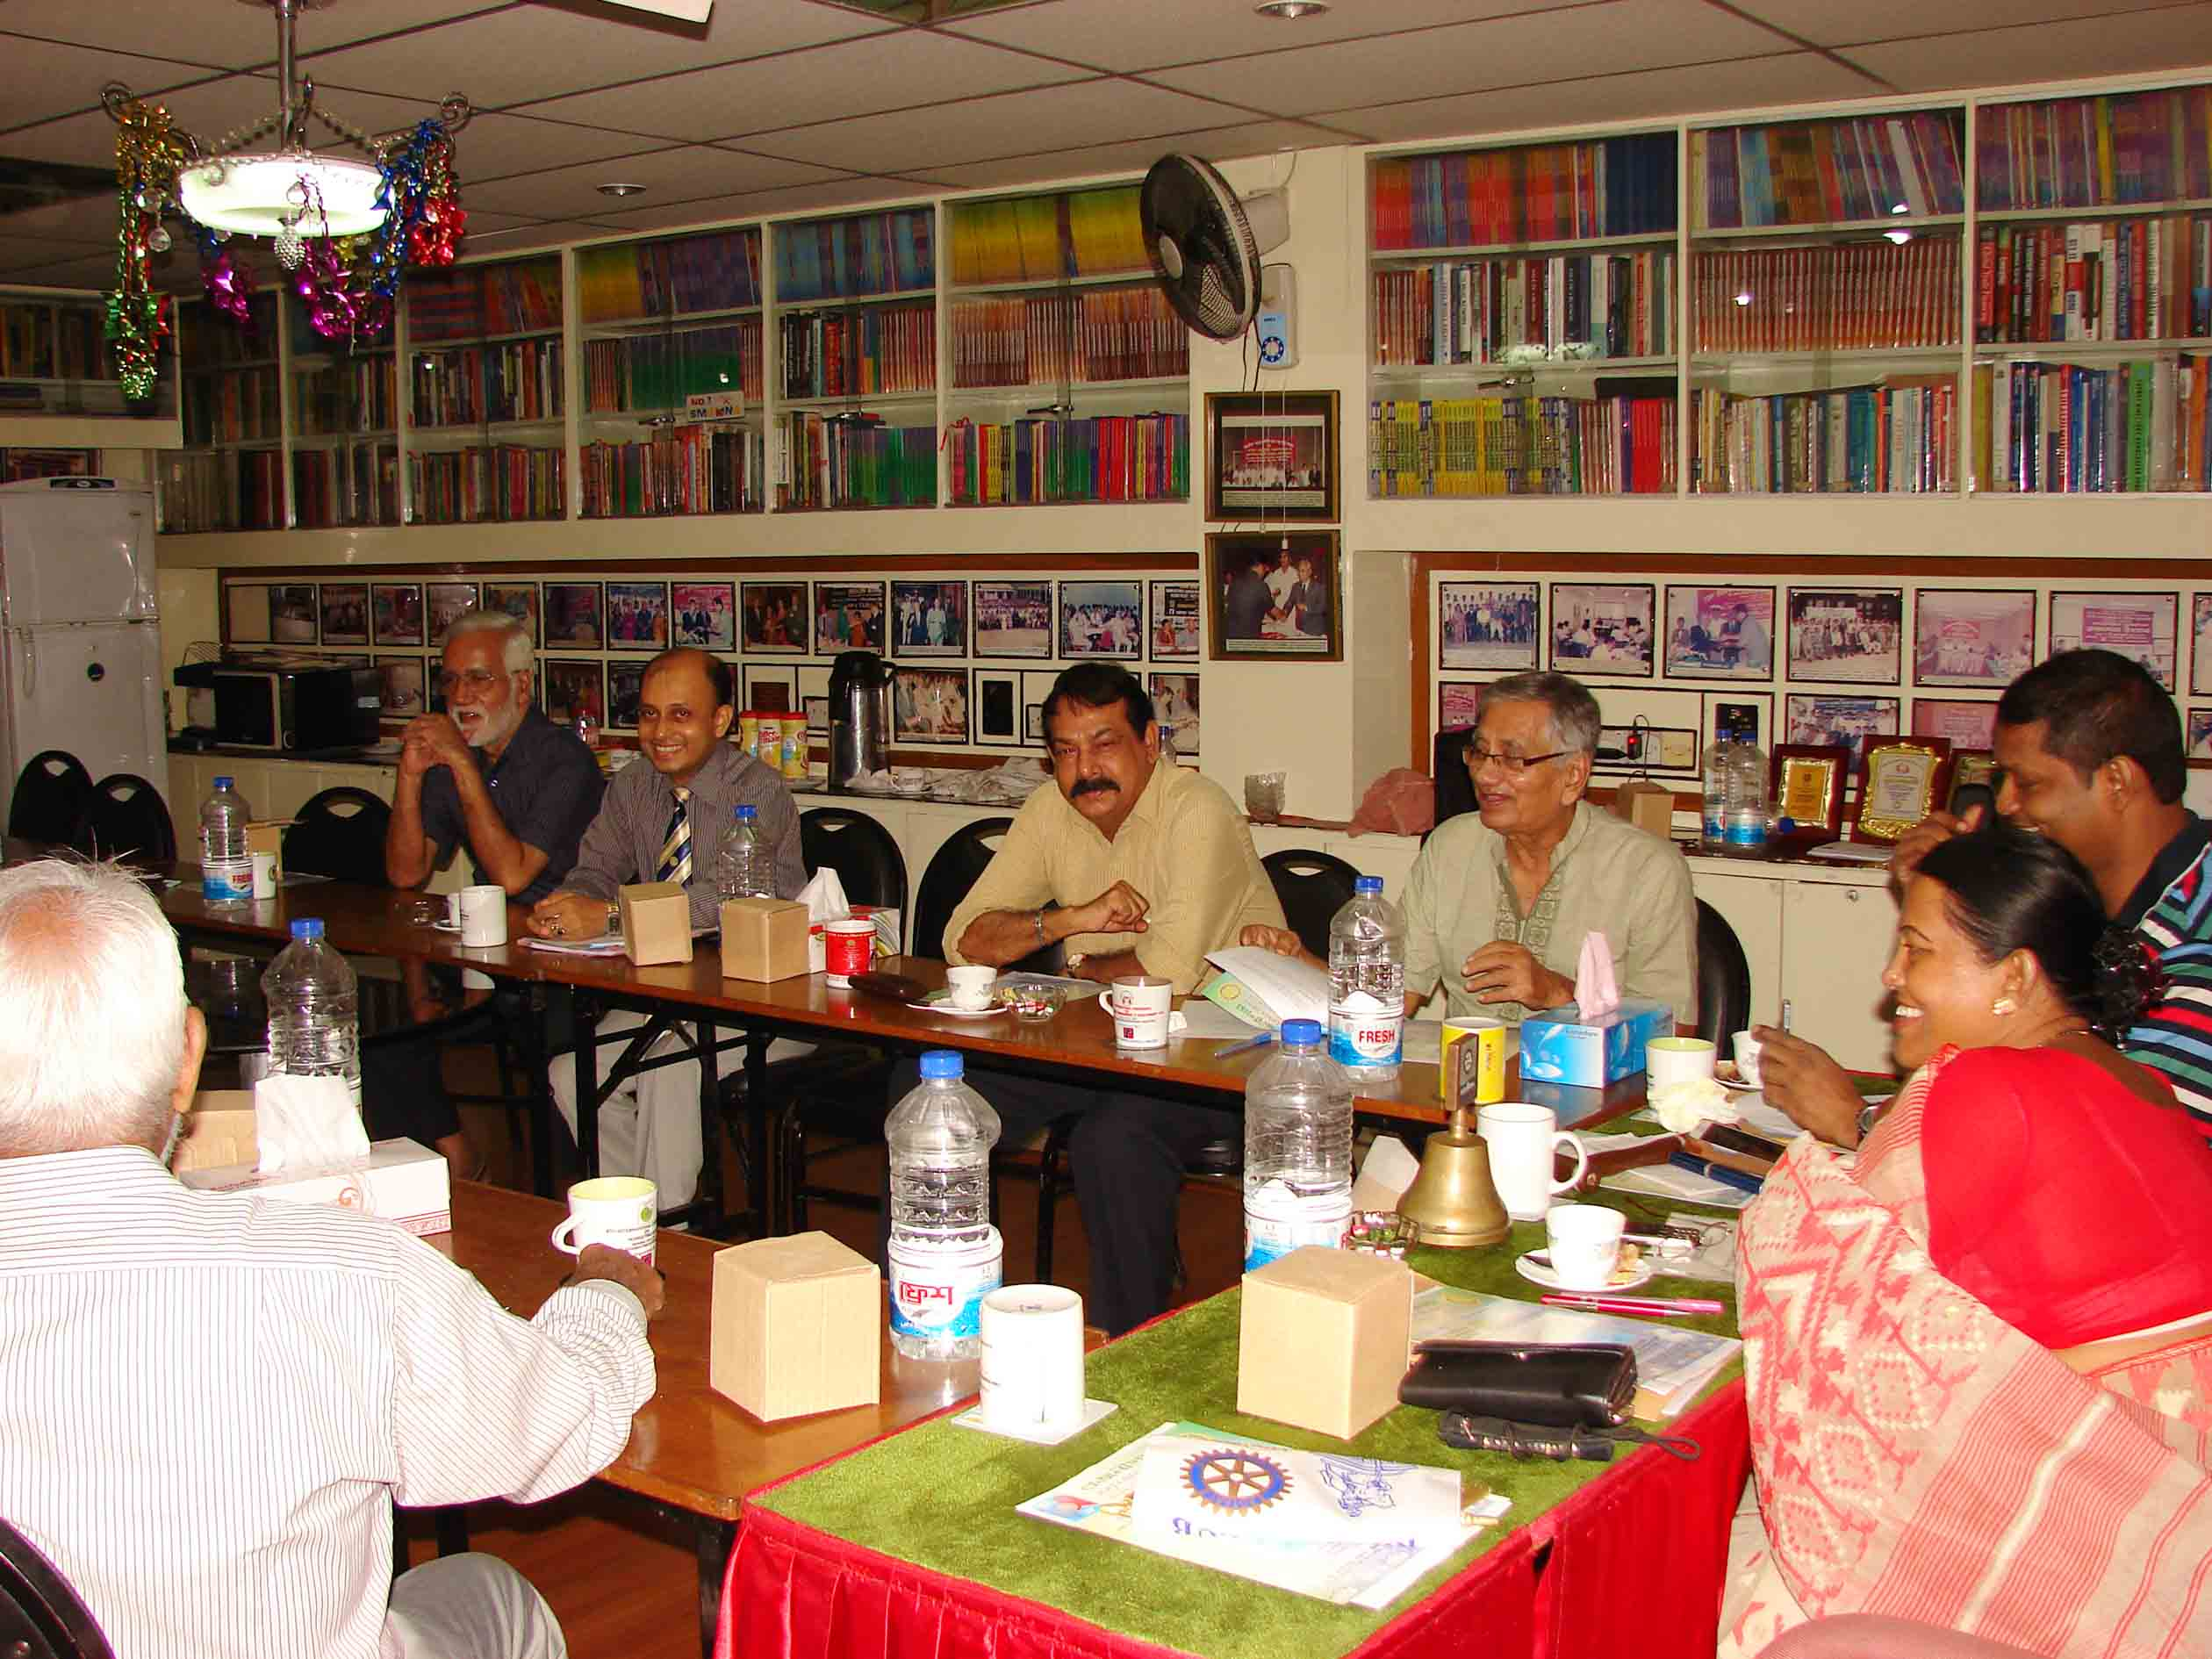

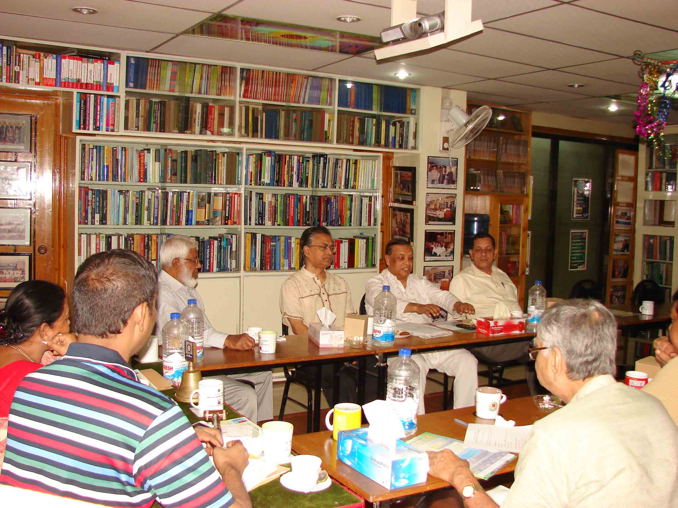
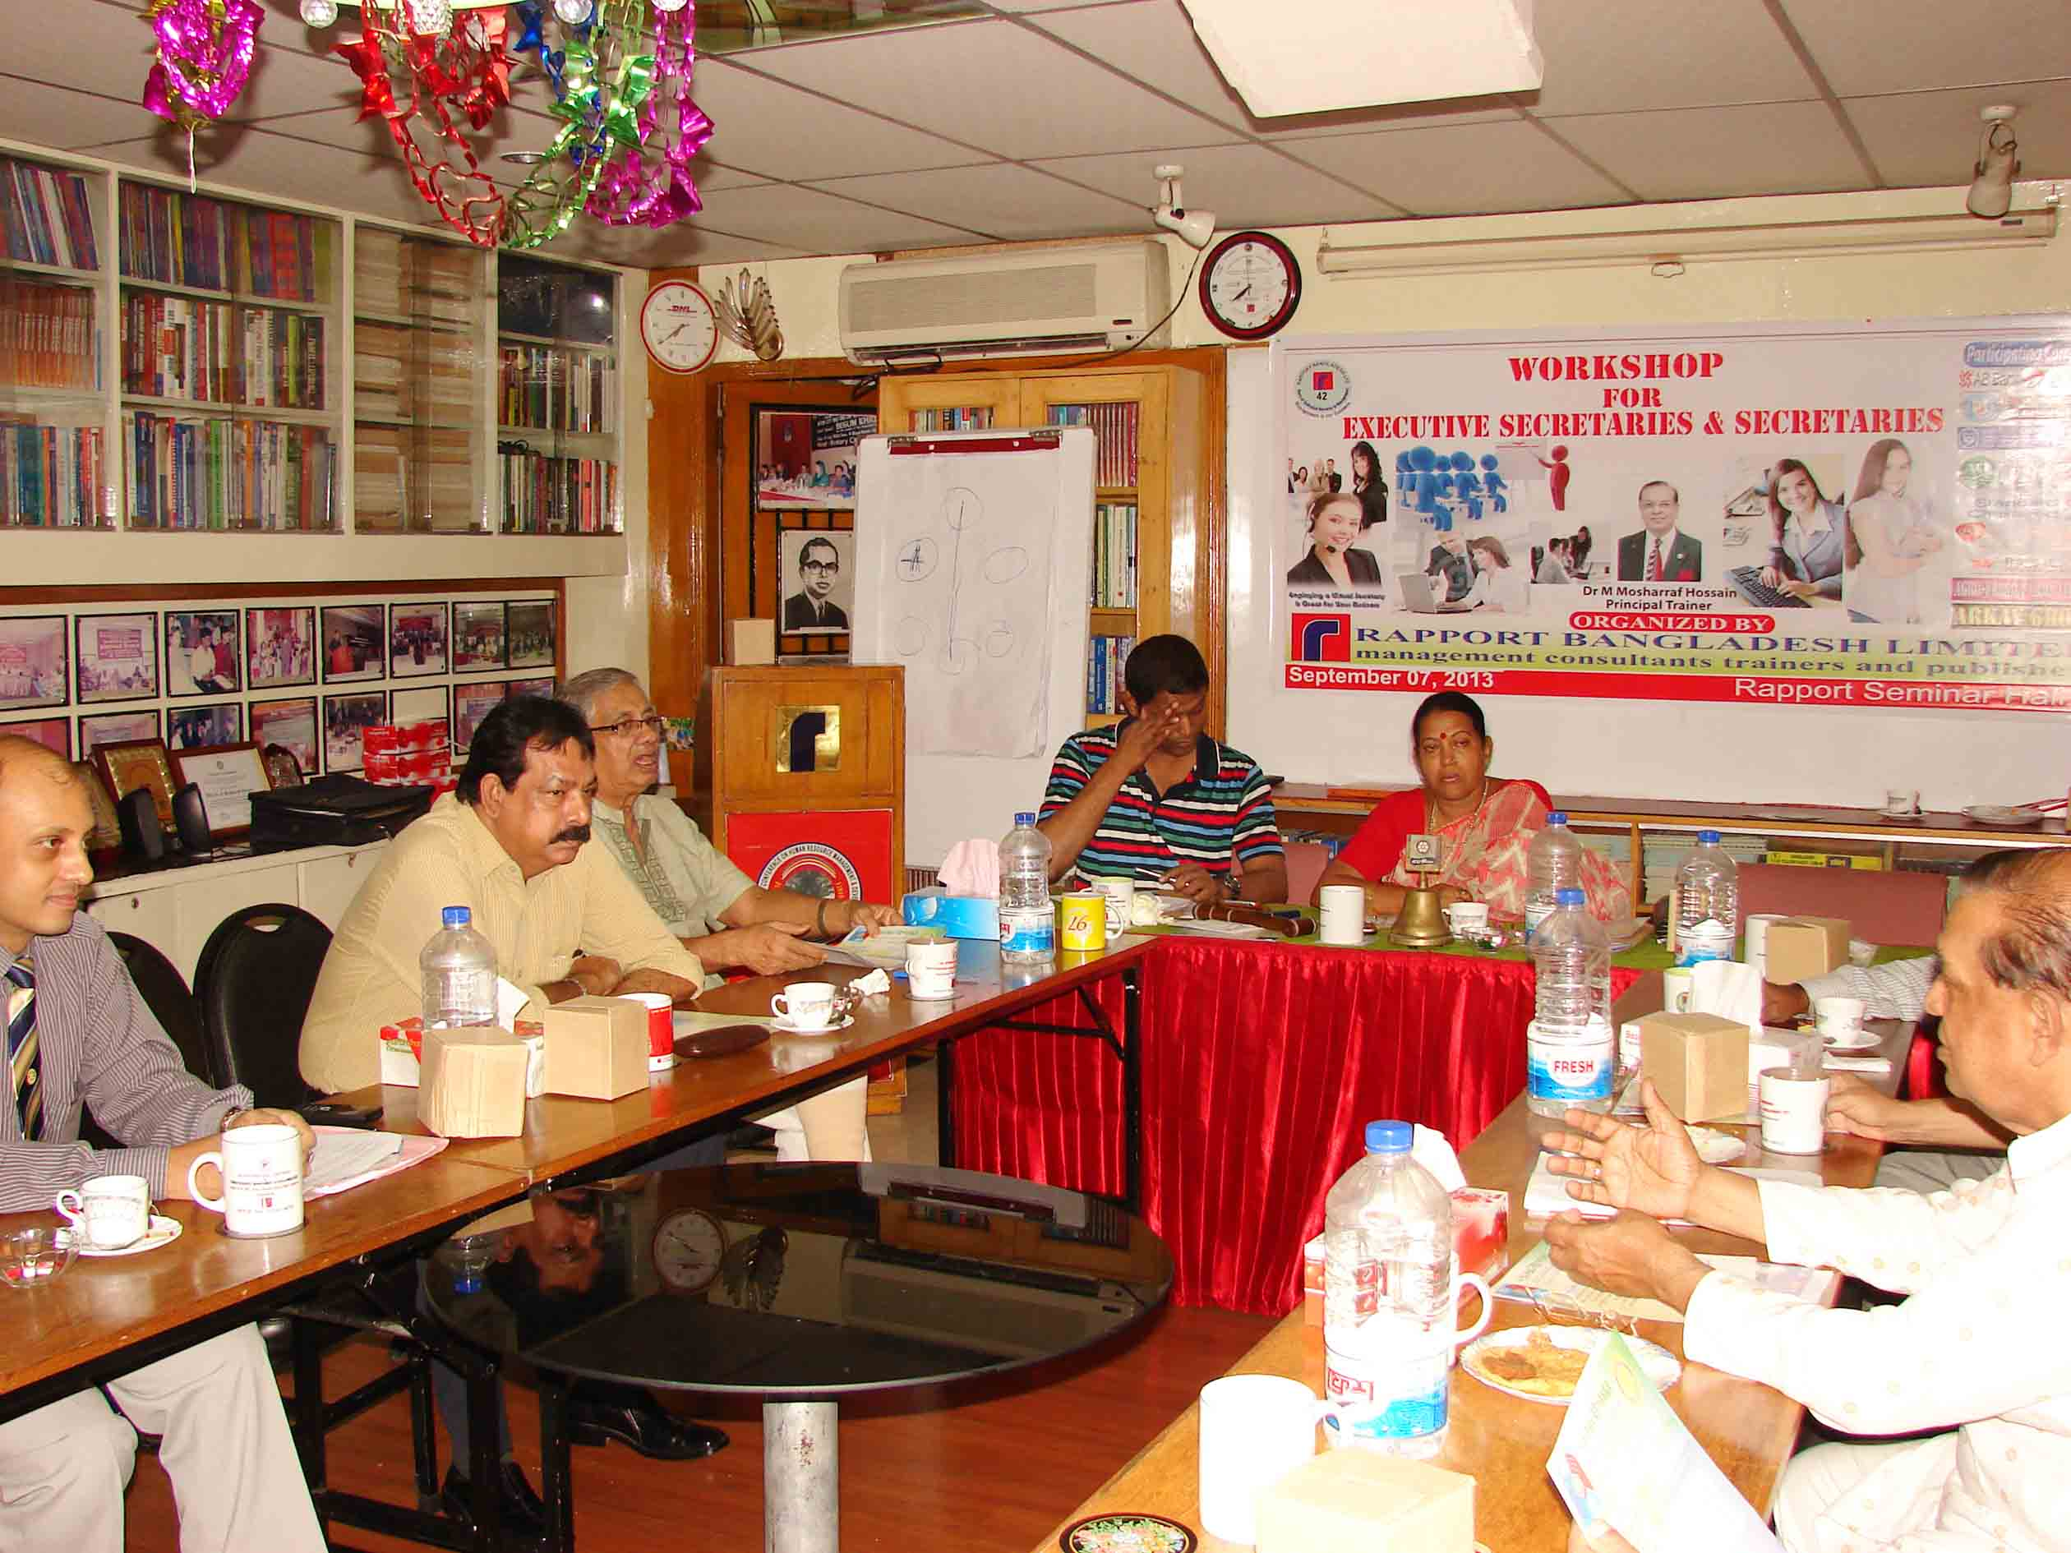

Sequences of the meeting
Rotary’s main objective is service - in the community, in the workplace, and around the globe. The 1.2 million Rotarians who make up more than 34,000 Rotary clubs in nearly every country in the world share a dedication to the ideal of Service Above Self.
Rotary clubs are open to people of all cultures and ethnicities and are not affiliated with any political or religious organizations.

Rotary International
The mission of The Rotary Foundation is to enable Rotarians to advance world understanding, goodwill, and peace through the improvement of health, the support of education, and the alleviation of poverty.
The Foundation is a not-for-profit corporation supported solely by voluntary contributions from Rotarians and friends of the Foundation who share its vision of a better world.

The Rotary Foundation

