Proceedings of the 1027th Regular weekly meeting of the club corresponding to the 18th meeting of Rotary year 2013-14 of Rotary Club of Sher-e-Banglanagar, Dhaka held on 18th January 2013 at 6:30 PM at Rapport Bangladesh Seminar Hall, Dhaka.

Meeting Called to order :

Rtn. Farida Parveen, President, Rotary Club of Sher-e-Banglanagar, Dhaka hereby called 1027th regular weekly meeting to order. She welcomed everybody and requested them to join the singing of the national anthem in chorus led by herself.

Rotary Invocation :

Rtn. Badoruzzaman Chowdhury led the Rotary Invocation.

The following members were Present in the meeting on 18th January 2013

Sl.No. | Members Present | We missed the fellowship of following Rotarians
01 | Rtn. Dr. M. Mosharraf Hossain | 01
02 | Rtn. Farida Parveen | 02 | PP Rtn. Dr. Shariful Islam
03 | Rtn. Bodoruzzaman Chowdhury | 03 | Rtn. Shibbir Ahmed Khan
04 | PP Rtn. M. A. Latif | 04 | Rtn. A B M Siddiq
05 | PP Rtn. M. R. Khan | 05 | PP Rtn. Tayebur Rahman
06 | Rtn. Asim Tarafder | 06 | IPP Rtn. M. Ali Hossain
07 | Rtn. Fariduddin Ahmmad | 07 | PP Rtn. ABM Sharif Uddin
08 | Rtn. Aahmed A Nabin | 08 | Rtn. Md. Sakhawat H. Bhuiyan
 |  | 09 | Rtn. Gofran Ahmed
 |  | 10 | PP Rtn. Sukriti Mukherjee
 |  | 11 | Rtn. Md. Nazim Uddin
 |  | 12 | PP Rtn. Dr. Abdus Sobhan
 |  | 13 | Rtn. Shahinoor Rahman

Felicitations:
There was no felicitation in this week.

President’s Mail:
No President’s mail was in this week.

Make-up by:
There was no advance make-up by the Rotarian.

Club Guest:
Rtn. Muhammad Ayub, PP, RC Narayanganj was present as club guest and deliver speech on membership development specially for spouse.

Member Guest:
No member guest was present.
Day’s Program:

The meeting started as per Agenda and the following agenda were discussed & adopted:

Secretary’s Announcement:

Rtn. PP M R Khan conducted the club business and announced that :

The 1028th regular weekly meeting of the club corresponding to the 19th meeting of Rotary Year 2013-14 would be held on 25th January, 2013 (Saturday) at 6:30 P.M. at RAPPORT Bangladesh Ltd., Dhaka.

Statistics of the Day:

Club Statistics was given by Rtn. PP M R Khan

Meeting No. 1027
Members on Roll 20
Members Present 08
Advance Make-up 00
Attendance Percentage 40%
Visiting Rotarians 00
Percentage of last meeting %

1st Comer of the Meeting : 1st comer of the meeting Rtn. Farid Uddin.

There being no other agenda the meeting was adjourned with a vote of thanks to the Chair.

Rtn. Farida Parveen Rtn. Shibbir Ahmed Khan
President Secretary
Photo gallery

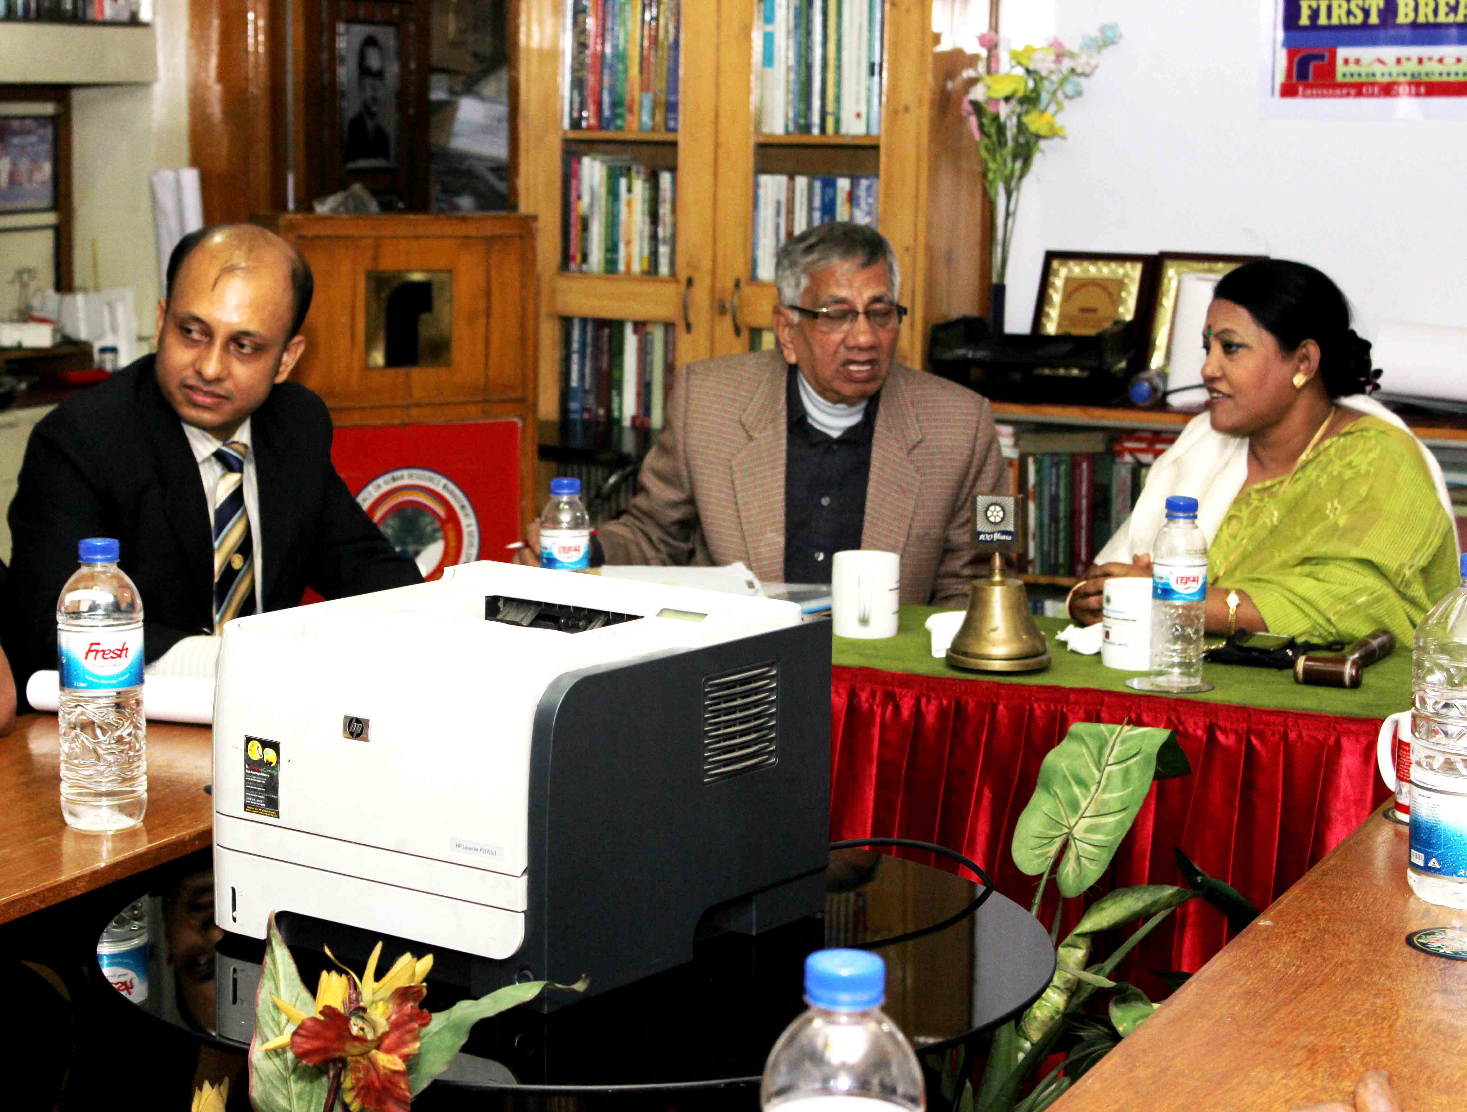
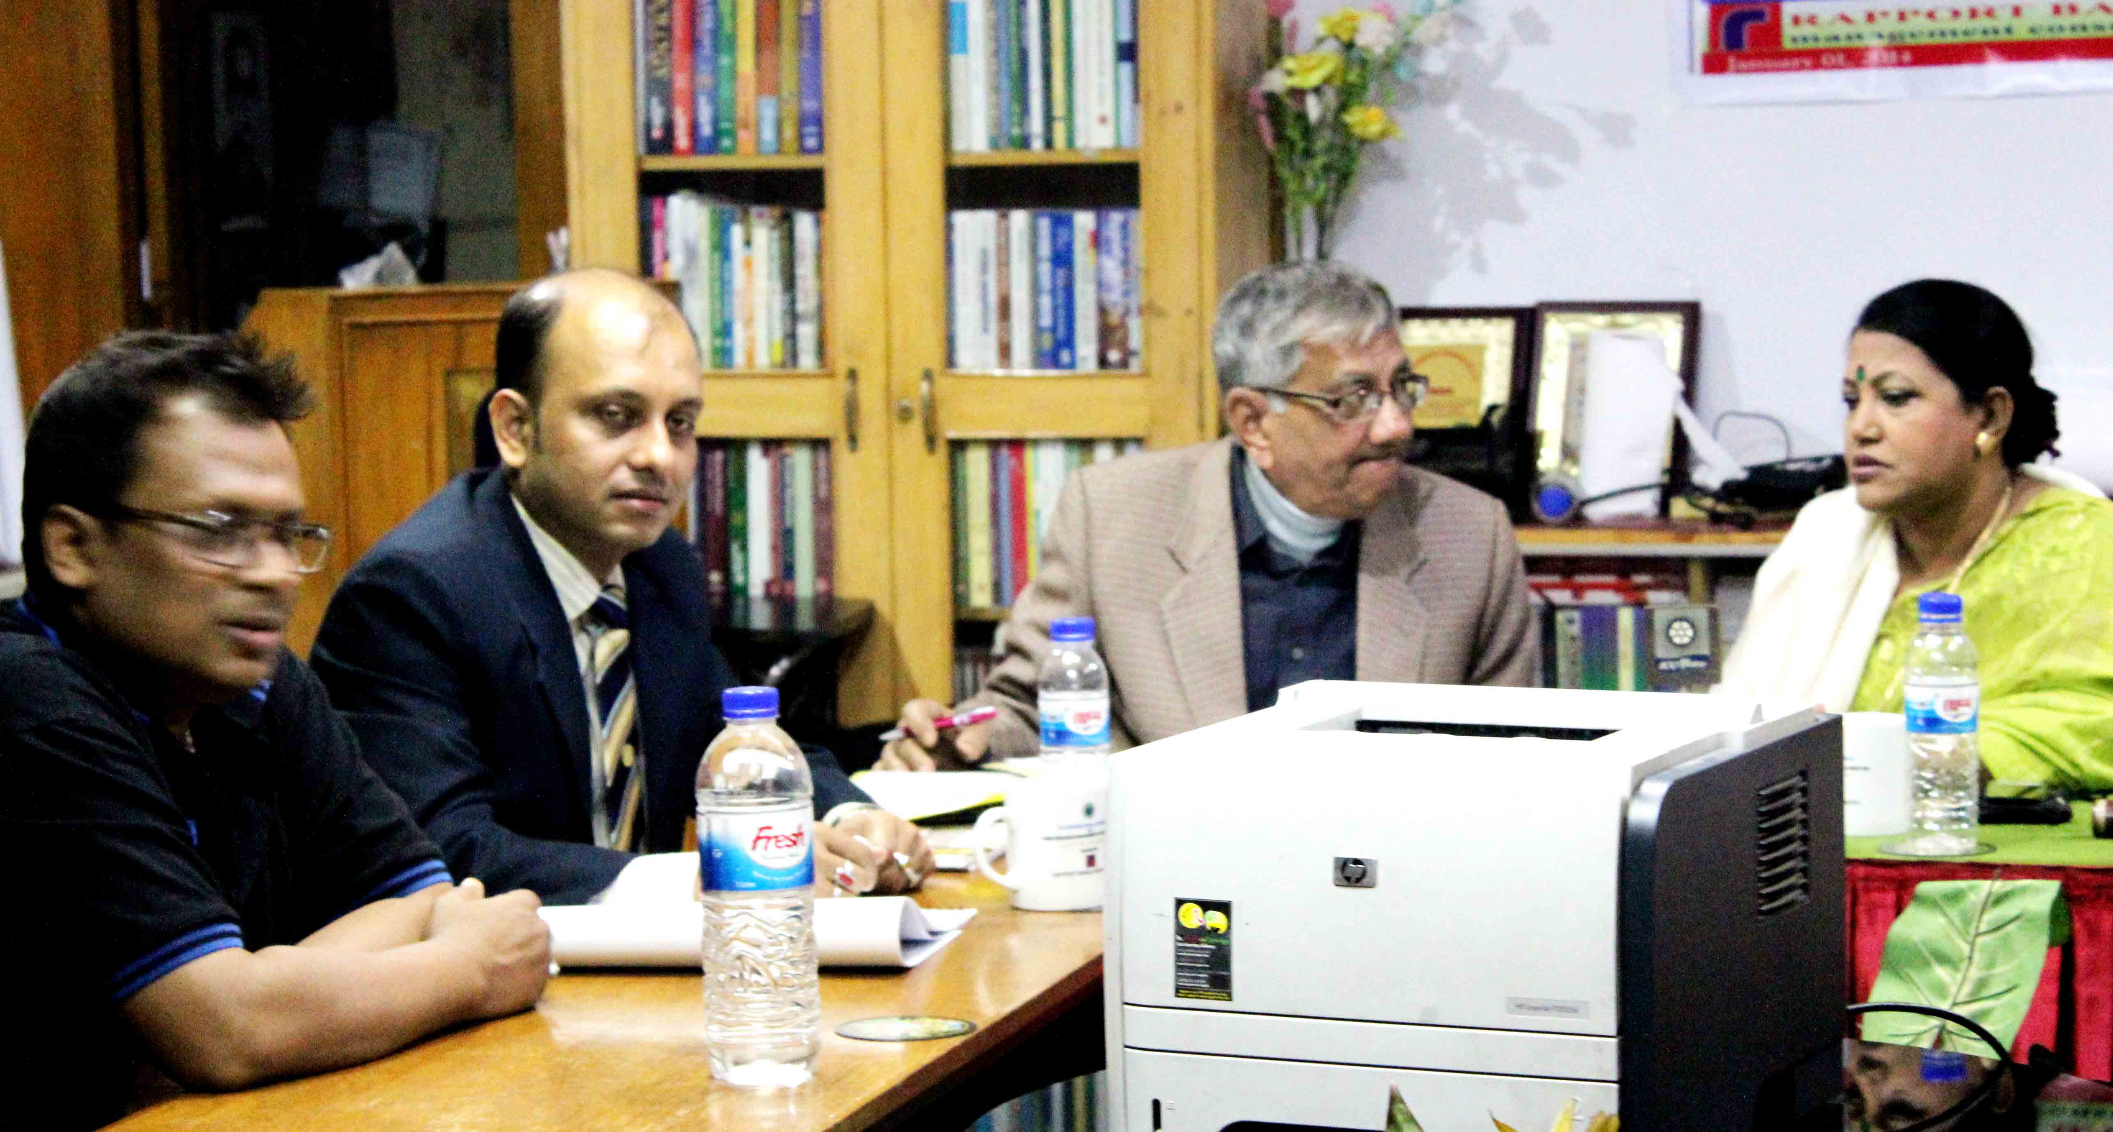
Sequences of the meeting

