1159st Regular Weekly Meeting
10th March 2018 at 6:30 PM
Rotary Center, Dhaka

Proceedings of the 1159th Regular weekly meeting of the club corresponding to the 17th meeting of Rotary year 2017-18 of Rotary Club of Sher-e-Bangla Nagar Dhaka held at Rotary Center, Dhaka on 10th March 2018 at 6:30 PM.

Meeting Called to order :

Rtn. Asim Tarafder, President, Rotary Club of Sher-e-Bangla Nagar Dhaka hereby called 1159th regular weekly meeting to order.

NATIONAL ANTHEM :
He welcomed and requested everybody to sing the national anthem in chorus led by IPP Rtn. Farida Parveen.

ROTARY INVOCATION :
PE Rtn. Ruhul Quddus Moni led the Rotary Invocation.

We enjoyed the fellowship of following Rotarians:
- PP Rtn. Tayebur Rahmna
- IPP Rtn. Farida Parveen
- PE Rtn. Ruhul Quddus Moni
- PP Rtn. ABM Sharif Uddin
- Rtn. Engr. Ashraful Huq
- Rtn. Aktaruzzaman Milon
- Rtn. Faiz Ahmed
- Rtn. Asim Tarafder

Introduction of Guest:
Rtn. Monjusree Dutta Papia from RC Scholars.

Day’s Program:

The meeting started as per Agenda and the following agenda were discussed and/or decisions were adopted:

- President informs that March is the month of Water and Sanitation. Then he discuss on this topic and added that we have already completed the project of supplying safe water in Borocow Primary School. Now we are constructing a sanitary latrine for specially girls.

- President requests everybody to physically attend the project of Breast and Cervical Cancer Screening Project at Manikganj. He also requests to confirm on or before 15th March evening.

- President proposes to arrange next meeting in Auchin Pakhi music school instead of the regular venue. In that meeting the scholarship cheque will be handed over to the school authority. Everybody appreciated the proposal and the decision has final final.

- President Rtn. Asim Tarafder then cordially requests everybody to pay the club dues if not paid yet. He also requests for project contribution and TRF contribution.

He added that we are going to achieve RI citation for the first time. But we have to fulfill one more criteria. For that ¾ persons need to contribute at least 25 $.

- President gives the floor to the secretary. Then Secretary informs about a financial transaction related issue by Rtn. Rabiul Islam. Rtn. Rabiuls cell phones are switched off for last many days. He syas that he already visited Rtn. Rabiul’s office and he could know that actually he is not with them anymore. President then supplemented that he has already got complains from our late PDG’s wife and also from a sufferer of Mohammad pur. So, Rtn. Rabiul have to to clear his position when he comes in meeting next time. If his explanation is not satisfactory then BOD will decide about him. But he may not be able to hold the position of Secretary for 2018-19.

- President says that as we are in crisis for a person who can take the responsibility of Secretary for next tenure so we can propose the visiting Rotarian Papiya to join our club after taking clearance from existing club and become the Secretary 2018-19. Everybody appreciate it with claps

- President proposes that every member has to submit his or her NID copy. From now on we must take a copy of NID from new members as well. We shall maintain a file with members detail information. Everybody accepted with full support.

Secretary’s Announcement:

The 1160th regular weekly meeting of the club corresponding to the 18th meeting of Rotary Year 2017-18 will be held on 24th March 2018 (Saturday) at 6:30 P.M. at Auchin Pakhi Music School, Tejkuni Para, Dhaka.

Statistics of the Day:
Meeting No. 1159
Members on Roll 18
Members Present 8
Advance Make-up 3
Attendance Percentage 60%
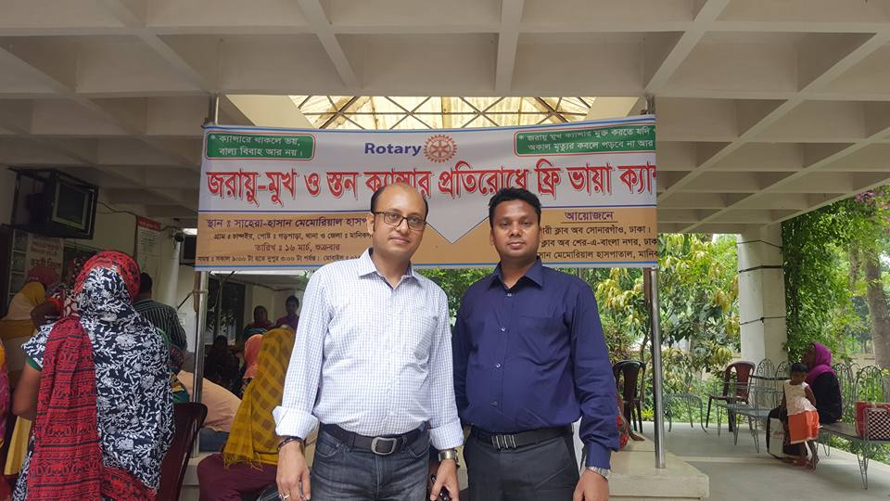
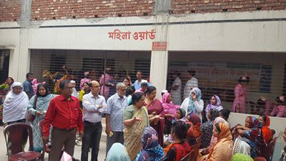
Project Activity & Photo Gallery

